**CHAPTER 1**

**Gesture Assistant**

**1.1 INTRODUCTION:**

**Python Programming** is an object-oriented, high-level programming language with integrated dynamic semantics primarily for web and app development. It is extremely attractive in the field of Rapid Application Development because it offers dynamic typing and dynamic binding options. Python programming is interpreted language which execute line by line.

**Artificial intelligence** (AI) is the simulation of human intelligence processes by machines, especially computer systems. These processes include learning , reasoning and self-correction.

* Particular applications of AI include  Expert system and Machine Learning

**Applications of artificial intelligence:**

1.Banking

2.Cyber Security

3.Virtual Assistants

4.Online Customer Support

5.Gaming

6.Speech Recognition

7.Robotics

8.Reasoning

**Gestures** are a form of nonverbal communication in which visible bodily actions are used to communicate important messages, either in place of speech or together and in parallel with spoken words. **Gestures** include movement of the hands, face or other parts of the body.

Gestures are culture-specific and can convey very different meanings in different social or cultural settings. Gesture is distinct from **sign language**.

**Gesture** based communication acknowledgement is an advancing exploration region. It is hard for them to do ordinary tasks of life. They can deal with correspondence by means of Indian gesture based communication. Hand signal acknowledgement.

***1.2 Objectives of research:***

* A new technology has been launched for easy deployment of motion based user interfaces for future connected home systems which offer an intuitive and smart way to control interactive content through hand and finger gestures.
* Logbar designed a smart wearable input device ring which enables the user to perform many tasks that include gesture control of smart appliances and devices synced to it, send texts, pay bills etc. with the help of finger movements.
* Research is being done to develop a chip that could be used for gesture recognition on headsets and smart watches using ultrasound gesture recognizer technology, unlike the devices that use light to recognize hand gestures.

***1.3 Problem statement:***

In the process of hand gesture recognition, the diversity and complexity of gesture will greatly influence the recognition rate and reliability. In the task of hand gesture recognition, the traditional method based on manual feature extraction is time-consuming and recognition rate is low. In order to improve the recognition rate, a novel recognition algorithm based on double channel **Convolutional Neural Network** (CNN) is proposed.

***1.4 Industry profile:***

Gesture recognition is conversion of a hominid movement or signal to a command using a mathematical algorithm. It enables any person to interrelate with the machine in absence of any physical devices, as an input mechanism to perform desired actions in a system. The technology interprets human gestures and movements, such as movement of hands, fingers, arms, head, or the entire body. It allows users to operate and control devices merely with their gestures.

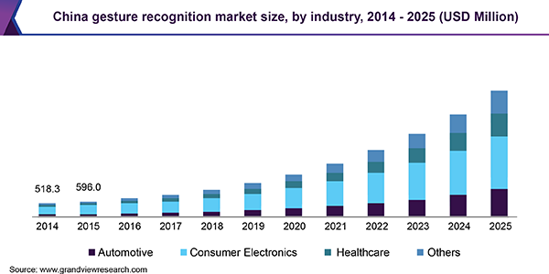

***China Gesture Recognition Market Size(2014-2025)***

Gesture recognition for PCs and desktops has been one of the trending aspects in the modern world of gadgetry. Human gesture recognition is one of the newest ways to input information or control a computer. This gesture recognition technology enables the user to naturally and intuitively interact with the computer making the PC viewing and usage experience more interactive and realistic.

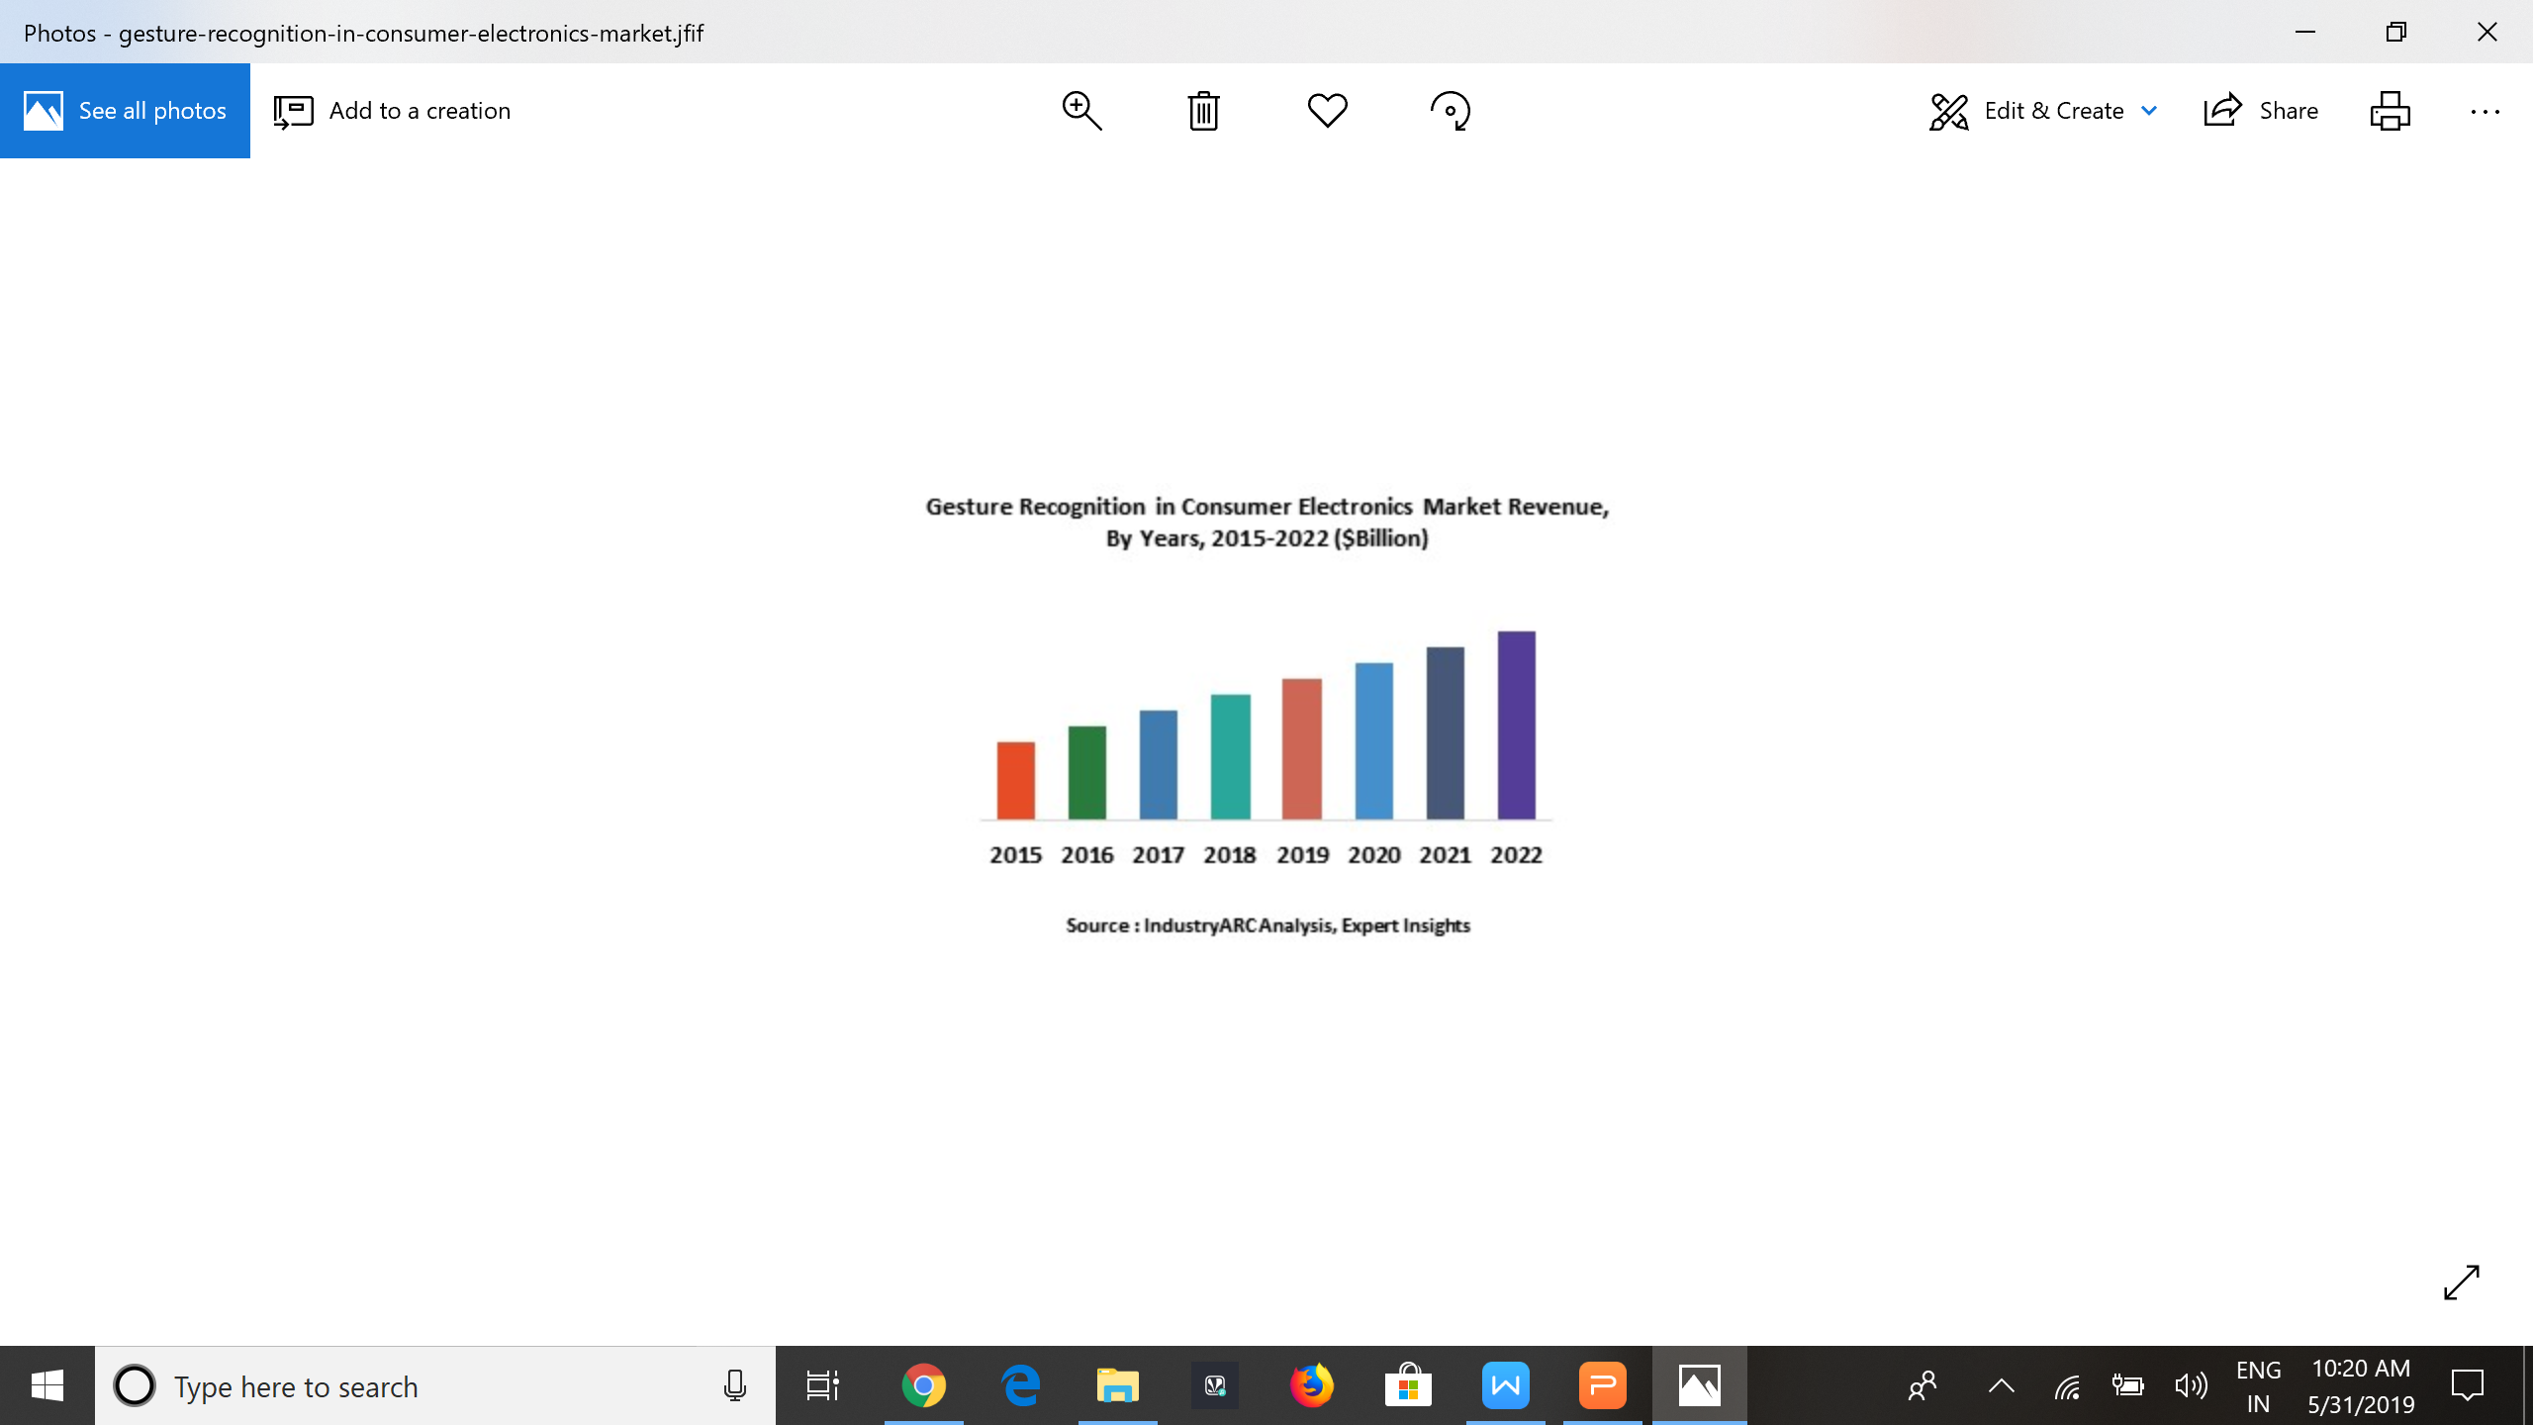

## **Major Players in Gesture Recognition  Market :**

The companies referred in the market research report include

Microsoft Corporation (U.S.)

Samsung Electronics (South Korea)

Intel Corporation (U.S.)

Sony Corporation (Japan)

Texas Instruments (U.S.)

Soft Kinetic (Belgium)

more than 10 other companies.

**CHAPTER 2**

**Review of literature**:

We applied multivariate Gaussian distribution to recognize hand gestures using non-

geometric features. The input hand image is segmented using two different methods ; skin color based segmentation by applying HSV color model and clustering based thresholding techniques. Some operations are performed to capture the shape of the hand to extract hand feature; the modified Direction Analysis Algorithm are adopted to find a relationship between statistical parameters from the data, and used to compute object(hand) slope and trend by finding the direction of the hand gesture.

**CHAPTER 3**

***Data Collection:***

In the field of the segmentation, different types of cameras are used for data

gathering (Fig. 1) to build up a gesture recognition system. The single color camera is the most common type of data acquisition tool because of its ease of use and fast data evaluation capability even with high resolution images. The stereo image evaluation forms another approach. In addition to the color information, the depth information, which is determined through a disparity calculation, is used. Nevertheless, the disadvantage of stereo calculation is the increased computational cost. The thermal forms the third type of data production. In this case, the temperature of an object is captured with the help of infrared radiations and afterwards shown in the image

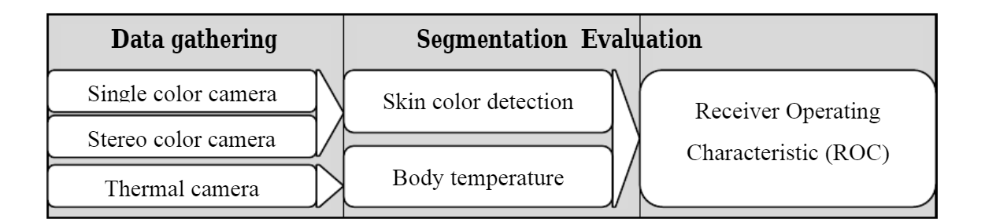

**Figure: Data gathering and evaluation for gesture and posture recognition**

**CHAPTER 4**

***Methodology :***

##### **Hand Detection:**

The overview of the hand gesture recognition is described in Figure. First, the hand is detected using the background subtraction method and the result of hand detection is transformed to a binary image. Then, the fingers and palm are segmented so as to facilitate the finger recognition. Moreover, the fingers are detected and recognized. Last, hand gestures are recognized using a simple rule classifier.

##### **Process-of-hand-gesture-recognition**

**Figure:Hand Detection Process**

##### ***Recognition of Hand Gestures***

When the fingers are detected and recognized, the hand gesture can be recognized using a simple rule classifier. In the rule classifier, the hand gesture is predicted according to the number and content of fingers detected. The content of the fingers means what fingers are detected. The rule classifier is very effective and efficient. For example, if three fingers, that is, the middle finger, the ring finger, and the little finger, are detected, the hand gesture is classified as the label 3 .

**Steps involved in Hand Gesture:**

**STEP 1:**

The original images used for hand gesture recognition in the work are demonstrated in Figure 1. These images are captured with a normal camera. These hand images are taken under the same condition. The background of these images is identical. So, it is easy and effective to detect the hand region from the original image using the background subtraction method. The skin color can be used to discriminate the hand region from the other moving objects. The color of the skin is measured with the HSV model. The image of the detected hand is re-sized to  to make the gesture recognition invariant to image scale.

[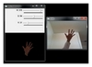](https://www.hindawi.com/journals/tswj/2014/267872/fig2/)

**Figure 1: The procedure of hand detection.**

##### **STEP 2:**

##### **Fingers and Palm Segmentation**

The output of the hand detection is a binary image in which the white pixels are the members of the hand region, while the black pixels belong to the background. An example of the hand detection result is shown in Figure 2. Then, the following procedure is implemented on the binary hand image to segment the fingers and palm.

[](https://www.hindawi.com/journals/tswj/2014/267872/fig3/)

**Figure 2:**The detected hand region.

**STEP 3:**

[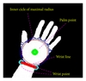](https://www.hindawi.com/journals/tswj/2014/267872/fig6/)

**Figure 3:** The palm point, wrist points, the wrist line, and the inner circle of the maximal radius.

* Inner Circle of the Maximal Radius. When the palm point is found, it can draw a circle with the palm point as the center point inside the palm. The circle is called the inner circle because it is included inside the palm. The radius of the circle gradually increases until it reaches the edge of the palm. That is the radius of the circle stops to increase when the black pixels are included in the circle. The circle is the inner circle of the maximal radius which is drawn as the circle with the red color in Figure 3.
* Wrist Points and Palm Mask. When the radius of the maximal inner circle is acquired, a larger circle the radius of which is 1.2 times of that of the maximal inner circle is produced. The circle is drawn as the blue color circle in Figure 3. Then, some points  are sampled uniformly along the circle. That is,where  is the position of the palm point,  is the radius of the circle, and  is the sampling step.

**STEP 4:**

Algorithm 1: The method of producing the palm mask.

[](https://www.hindawi.com/journals/tswj/2014/267872/fig7/)

**Figure 4:** The palm mask.

Two wrist points are the two ending points of the wrist line across the bottom of the hand. The wrist points are important points for hand gesture recognition. They can be searched in the following manner: if the distance between two successive mask points  are large, these two mask points are judged as the wrist points. That is,where  is the set of palm mask points and  is the distance between two points. Please refer to Figure 3 for the wrist points and wrist line.

**STEP 5:**

[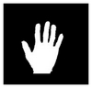](https://www.hindawi.com/journals/tswj/2014/267872/fig8/)

**Figure 5:**The rotated and cut hand image.

Hand Rotation, when the palm point and wrist point are obtained,it can yield an arrow pointing from the palm point to the middle point of the wrist line at the bottom of the hand. Then, the arrow is adjusted to the direction of the north. The hand image rotates synchronously so as to make the hand gesture invariant to the rotation. Meanwhile, the parts below the wrist line in the rotated image are cut to produce an accurate hand image that does not enclose the part of the arm.

**STEP 6:**

##### ***Fingers Recognition***

After the palm line is obtained, it is divided into 4 parts. According to the horizontal coordinate of the center point of a finger, it falls into certain parts. If the finger falls into the first part, it is the forefinger. If the finger belongs to the second part, it is the middle finger. The third part corresponds to the ring finger. The fourth part is the little finger. In the figure, the yellow line is the palm line and the red line parallels to the wrist line.

[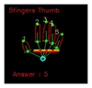](https://www.hindawi.com/journals/tswj/2014/267872/fig12/)

**Figure 6:**The recognition of the fingers.

In some case, two or more fingers stay closely and there is no interval among the fingers. In order to discriminate the case from that of a single finger, the width of the minimal bounding box is used as a discrimination index. If the width of the minimal bounding box is equal to a usual value, the detected region is a single finger. If the width of the minimal bounding box is several times of the usual value, the detected region corresponds to several fingers that stay together closely. For the robustness of finger recognition, the distances and angles between fingers are also taken into account to discriminate different gestures.

**CHAPTER 5**

***Findings and suggestions:***

* Project which we have done is very useful to the deaf and dum people to communicate with normal persons and to understand the others perspective.
* This gestures are where useful to the speakers while communicating with sign language.
* In the future it is very upcoming technology to the disabled persons.

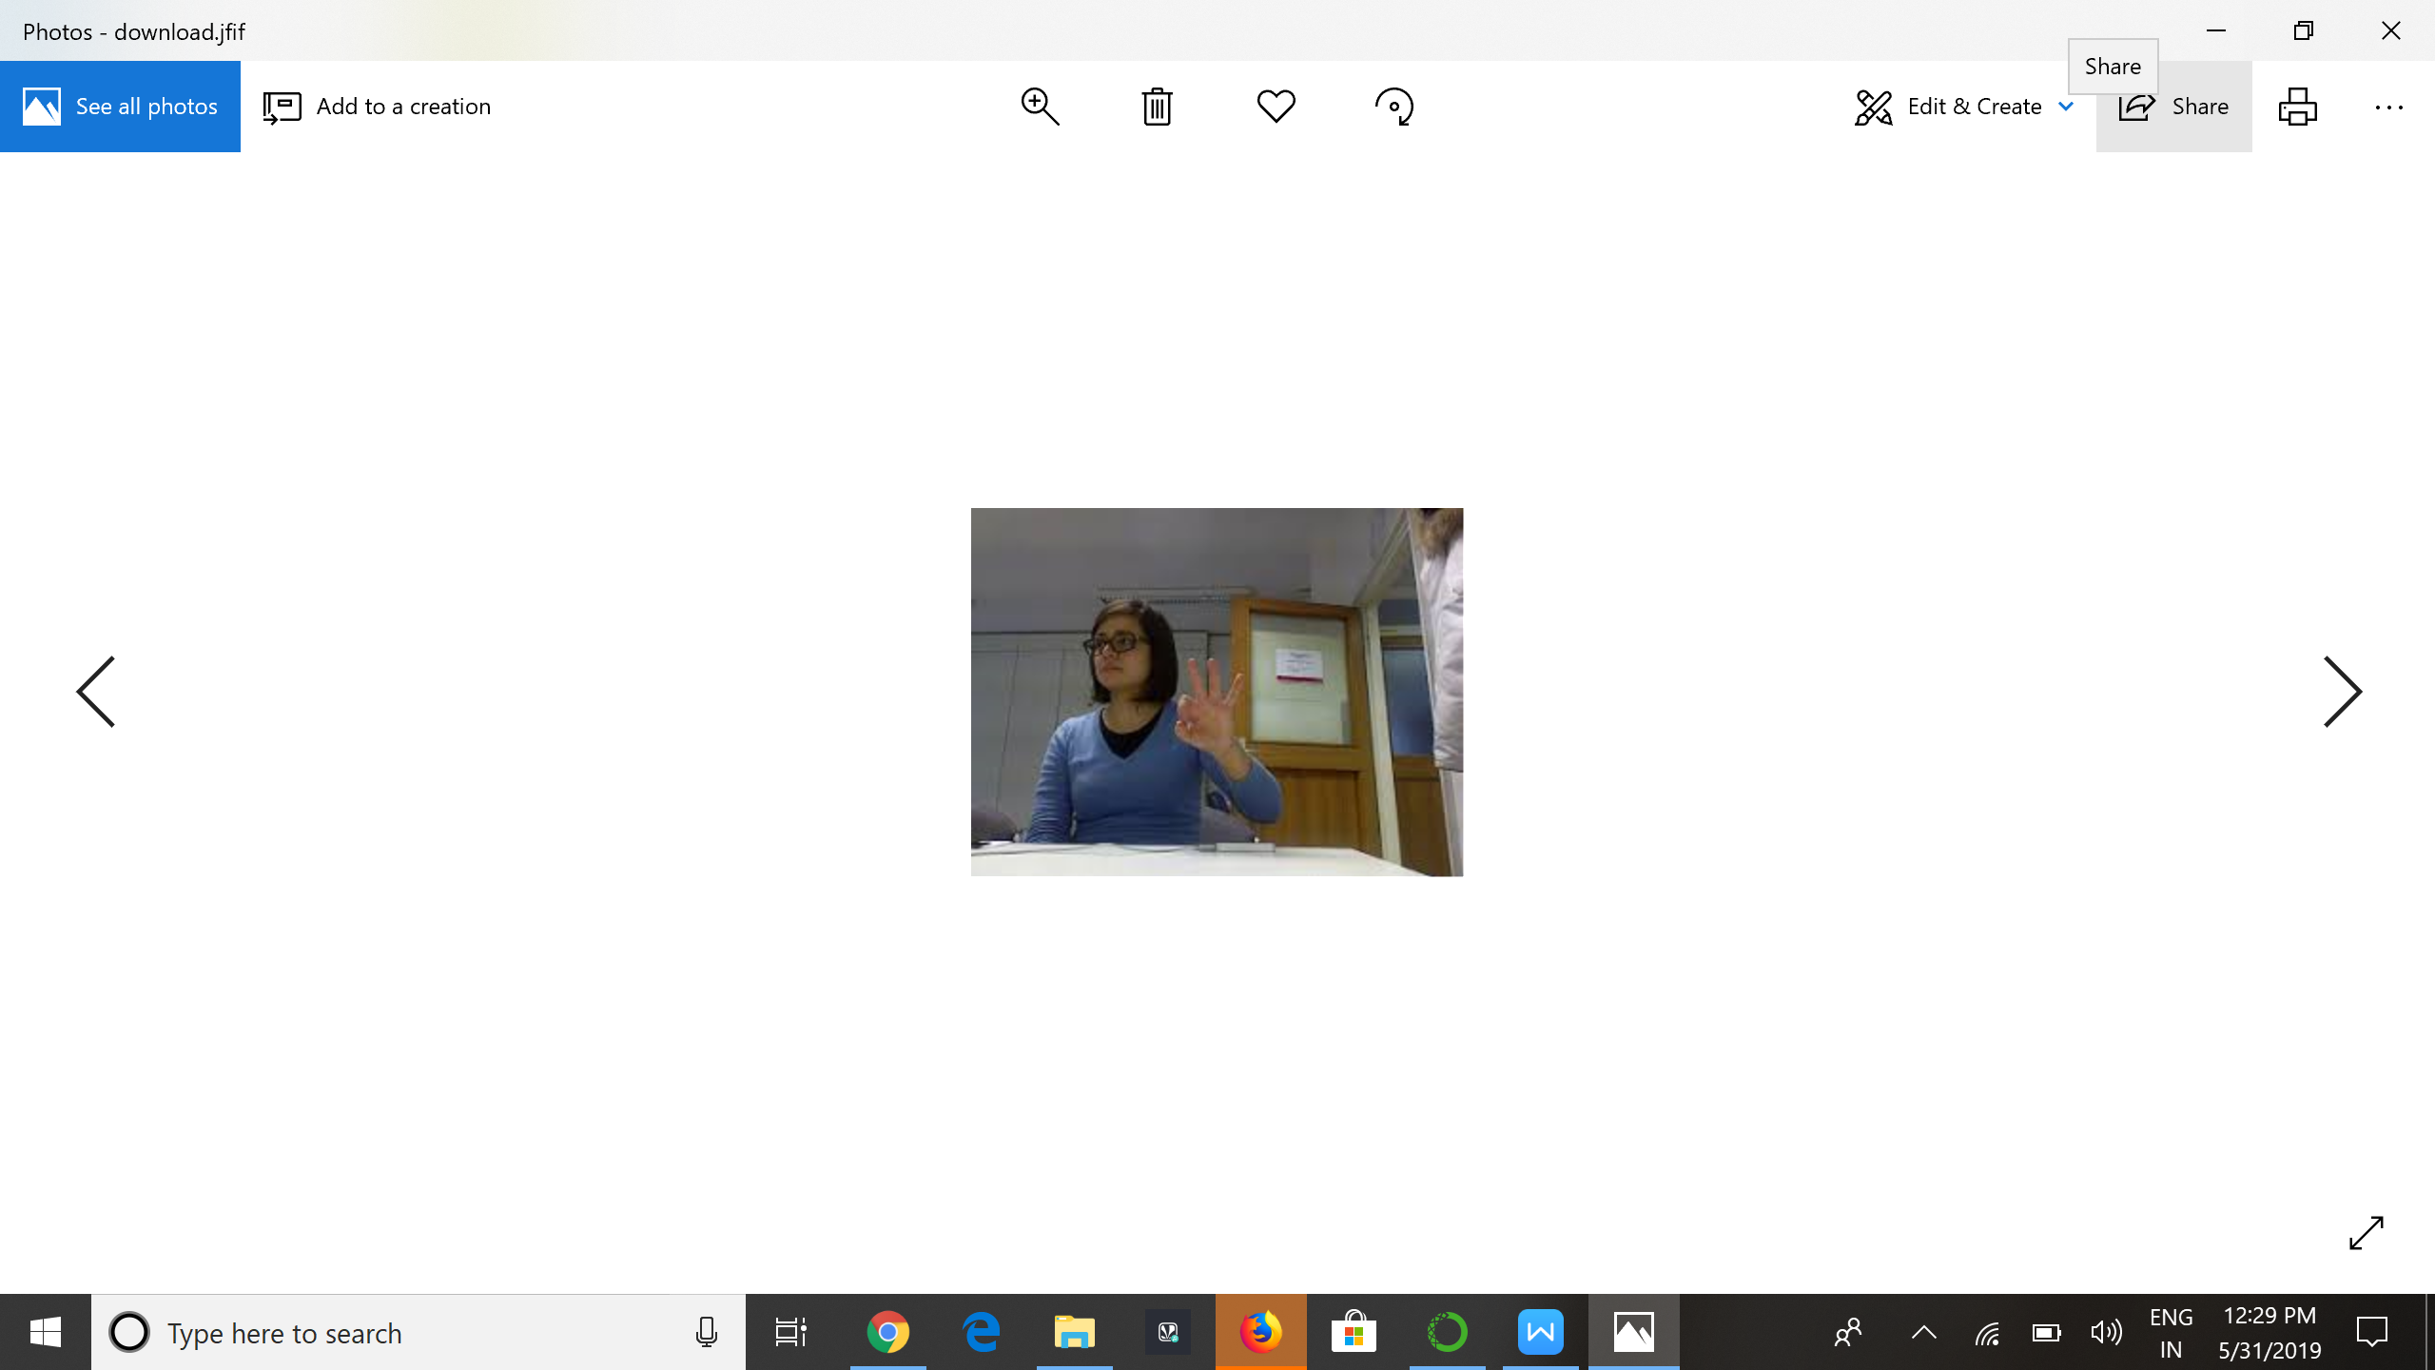

**CHAPTER 6**

**Conclusion:**

A new method for hand gesture recognition is introduced in this paper. The hand region is detected from the background by the background subtraction method. Then, the palm and fingers are segmented. On the basis of the segmentation, the fingers in the hand image are discovered and recognized. The recognition of hand gestures is accomplished by a simple rule classifier. By this hand gesture recognition we can communicate with the dum and deaf people very easily.

**CHAPTER 7**

**Appendix**

# -*- coding: utf-8 -*-

"""

Spyder Editor

This is a temporary script file.

"""

import cv2

import imutils

import numpy as np

import keras

from keras.models import load_model

from PIL import ImageTk, Image

from keras.preprocessing import image

from skimage.transform import resize

model = load_model(r'C:\Users\vineetha chowdary\mymodel.h5')

model.compile(loss = keras.losses.categorical_crossentropy, optimizer=keras.optimizers.Adam(),

metrics=['accuracy'])# global variables

bg = None

def run_avg(image, aWeight):

global bg

# initialize the background

if bg is None:

bg = image.copy().astype("float")

return

# compute weighted average, accumulate it and update the background

cv2.accumulateWeighted(image, bg, aWeight)

def segment(image, threshold=25):

global bg

# find the absolute difference between background and current frame

diff = cv2.absdiff(bg.astype("uint8"), image)

# threshold the diff image so that we get the foreground

thresholded = cv2.threshold(diff,

threshold,

255,

cv2.THRESH_BINARY)[1]

# get the contours in the thresholded image

_,cnts,_= cv2.findContours(thresholded.copy(),

cv2.RETR_EXTERNAL,

cv2.CHAIN_APPROX_SIMPLE)

# return None, if no contours detected

if len(cnts) == 0:

return

else:

# based on contour area, get the maximum contour which is the hand

segmented = max(cnts, key=cv2.contourArea)

return (thresholded, segmented)

if __name__ == "__main__":

aWeight = 0.5

camera = cv2.VideoCapture(0)

# region of interest (ROI) coordinates

top, right, bottom, left = 25, 350, 225, 590

# initialize num of frames

num_frames = 0

while(True):

# get the current frame

(grabbed, frame) = camera.read()

# resize the frame

frame = imutils.resize(frame, width=700)

# flip the frame so that it is not the mirror view

frame = cv2.flip(frame, 1)

# clone the frame

clone = frame.copy()

# get the height and width of the frame

(height, width) = frame.shape[:2]

# get the ROI

roi = frame[top:bottom, right:left]

# convert the roi to grayscale and blur it

gray = cv2.cvtColor(roi, cv2.COLOR_BGR2GRAY)

gray = cv2.GaussianBlur(gray, (7, 7), 0)

# to get the background, keep looking till a threshold is reached

# so that our running average model gets calibrated

if num_frames < 30:

run_avg(gray, aWeight)

else:

# segment the hand region

hand = segment(gray)

# check whether hand region is segmented

if hand is not None:

# if yes, unpack the thresholded image and

# segmented region

(thresholded, segmented) = hand

# draw the segmented region and display the frame

cv2.drawContours(clone, [segmented + (right, top)], -1, (0, 0, 255))

img = cv2.cvtColor(thresholded, cv2.COLOR_GRAY2BGR)

test_image = resize(img,(128,128))

test_image = image.img_to_array(test_image)

test_image = np.expand_dims(test_image, axis = 0)

prediction = model.predict_classes(test_image)

print(prediction)

if(prediction[0]==0):

cv2.putText(clone, "Hi", (10, 30),cv2.FONT_HERSHEY_SIMPLEX, 0.7, (0, 0, 255), 2)

elif(prediction[0]==1):

cv2.putText(clone, "How are you", (10, 30),cv2.FONT_HERSHEY_SIMPLEX, 0.7, (0, 0, 255), 2)

elif(prediction[0]==2):

cv2.putText(clone, "I need some help", (10, 30),cv2.FONT_HERSHEY_SIMPLEX, 0.7, (0, 0, 255), 2)

cv2.imshow("Thesholded", thresholded)

# draw the segmented handA

cv2.rectangle(clone, (left, top), (right, bottom), (0,255,0), 2)

# increment the number of frames

num_frames += 1

# display the frame with segmented hand

cv2.imshow("Video Feed", clone)

# observe the keypreAss by the user

keypress = cv2.waitKey(1) & 0xFF

# if the user pressed "q", then stop looping

if keypress == ord("q"):

break

**Reference:**

<https://github.com/SparshaSaha/Hand-Gesture-Recognition-Using-Background-Elllimination-and-Convolution-Neural-Network/tree/master/Dataset>